SPECIALTIES

* UI/UX Design
* Interaction Design
* Project Management
* Story Boarding
* Style Boarding
* Prototyping
* Graphic Design
* SVG Icons
* Illustration
* Typography

EXPERIENCE

1998 – present

Always Freelancing

Tennessee Dept of Education

Contract, Nashville, TN, 12/2016 – 06/2017

Civic Inc.

Contract, Nashville, TN, 09/2013 – 02/2015

JPay.com

Full-time, Miami, FL, 2008 – 2013

Many projects, basically a one-man Web Dev department

• JPay.com

• Mobile App

• Phablet App B2C

* MLotto Project App & Website

Safari Ltd.

Contract, Miami, FL, 2007 – 2008

Planning Group Int. (now Sapient Nitro)

Contract, Miami, FL, 2006

Diaz & Cooper Adv.

Full-time, Miami, FL, 2003 – 2006

Art Director & Web Designer at TBWA

Full-time, London UK, 1998 – 2000

TOOLS

* Sketch
* Adobe Creative Suite
* Affinity Designer & Photo
* NPM / WebPack
* HTML/CSS
* SASS
* Vue.js
* Vue/Nuxt
* Angular
* Bootstrap

EDUCATION

International Fine Arts College, 1987,

Miami, FL, Commercial Art, AA Degree

Trent College, 1984, Long Eaton, UK

Boarding school in England, received Art Scholarship. Played Rugby for my county.

Profile

Guru-level with Adobe CS, Sketch. Axure wireframing, though often straight to Bootstrap design in-browser. Love reducing complexity to simplicity. When the UI is designed well, the user interface seems inevitable.

REFERRALS

*Don Pham*

Project Manager

don.kim.pham@gmail

(954) 801-9975

*Mike Mack*

Coder

mikemack88@gmail.com

(415) 509-1909

*Joanna Perry*

Creative Director

joanna@nomadhome.net

+44 788-418-7100

*PORTFOLIO*

Tennessee Dept of Education, Education Preparation Provider Portal (EPP)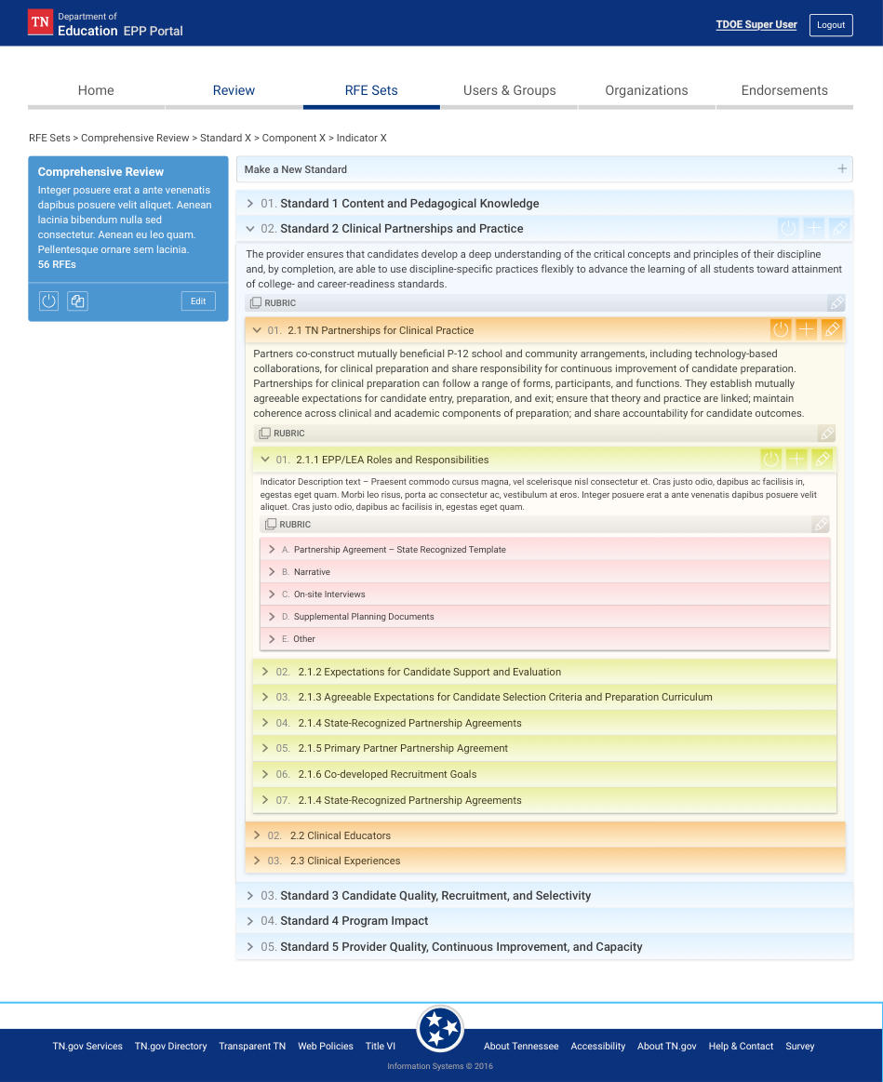

*PORTFOLIO*

Civic Inc, Bridge Admin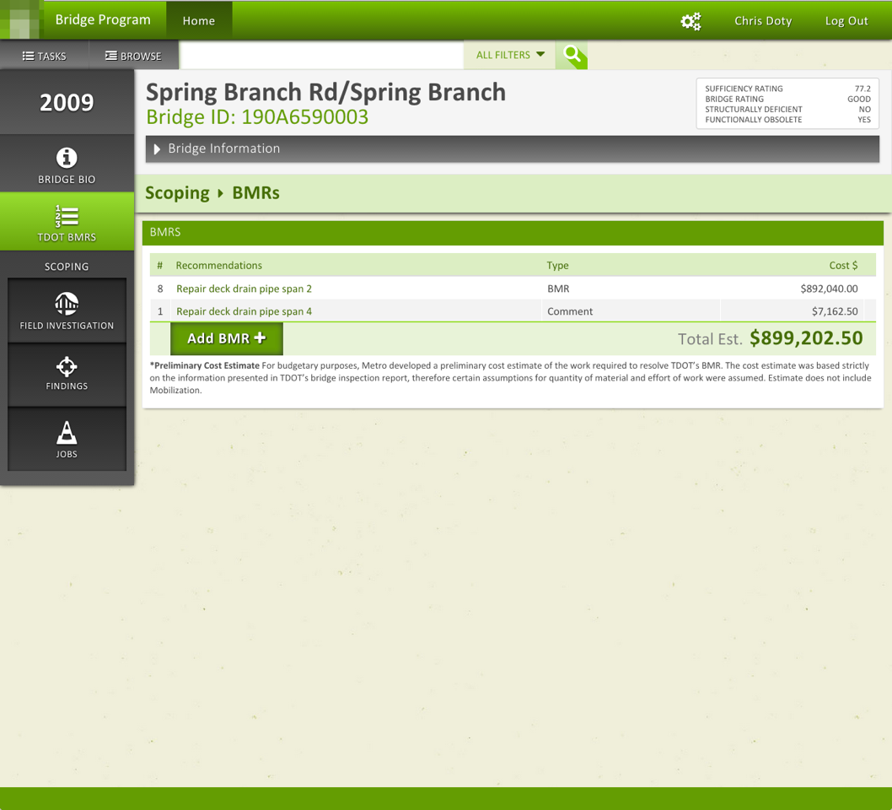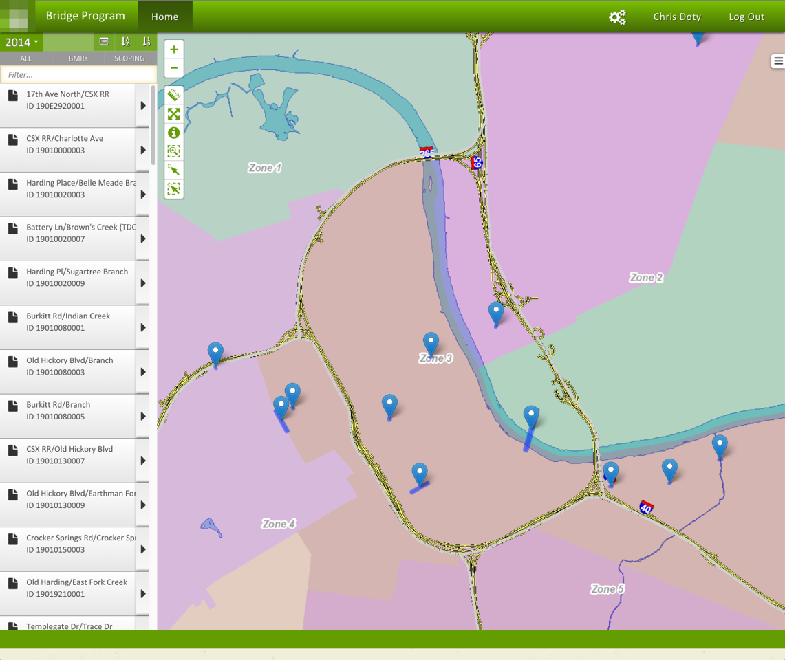

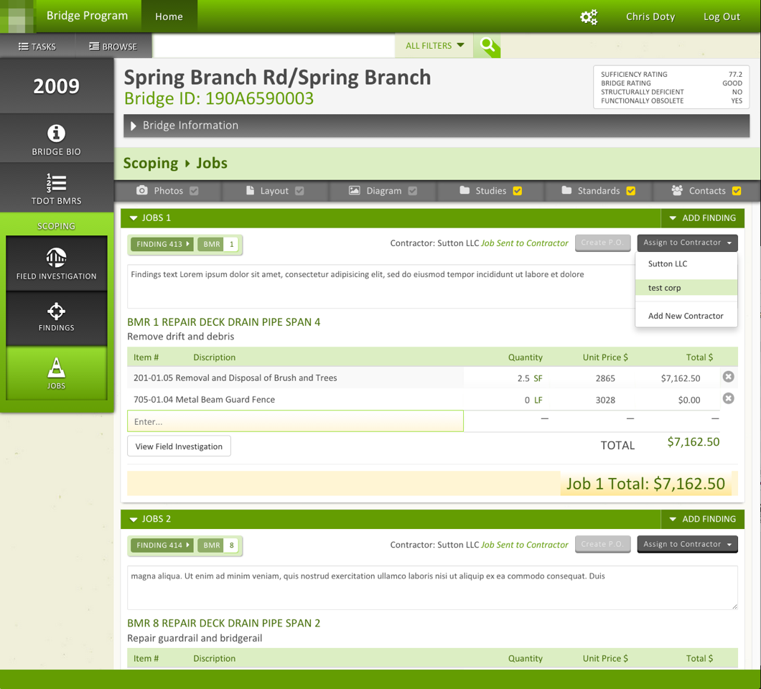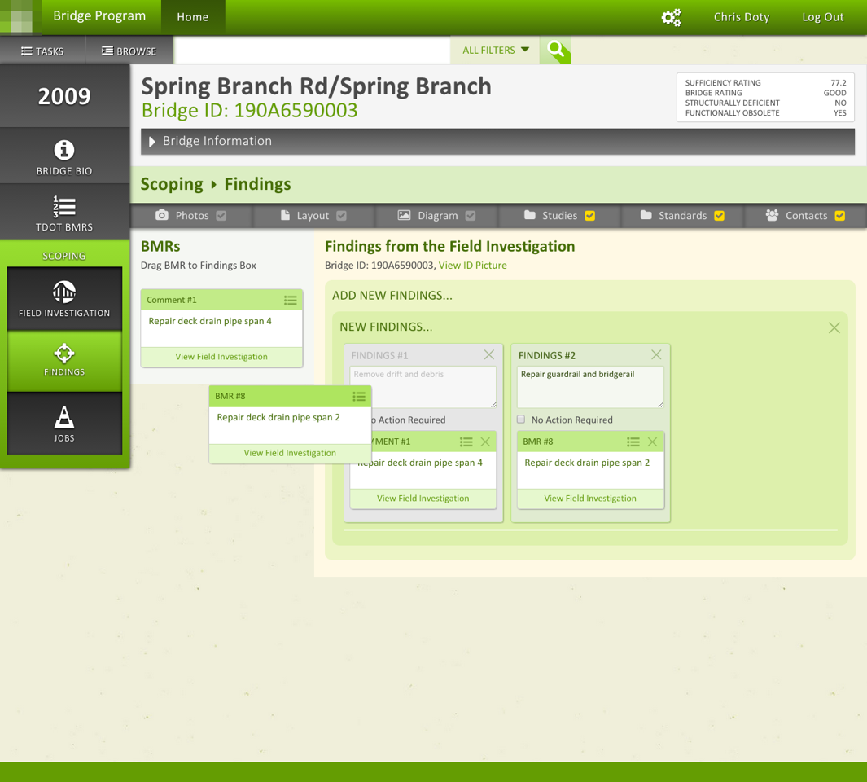

Civic Inc, Land Management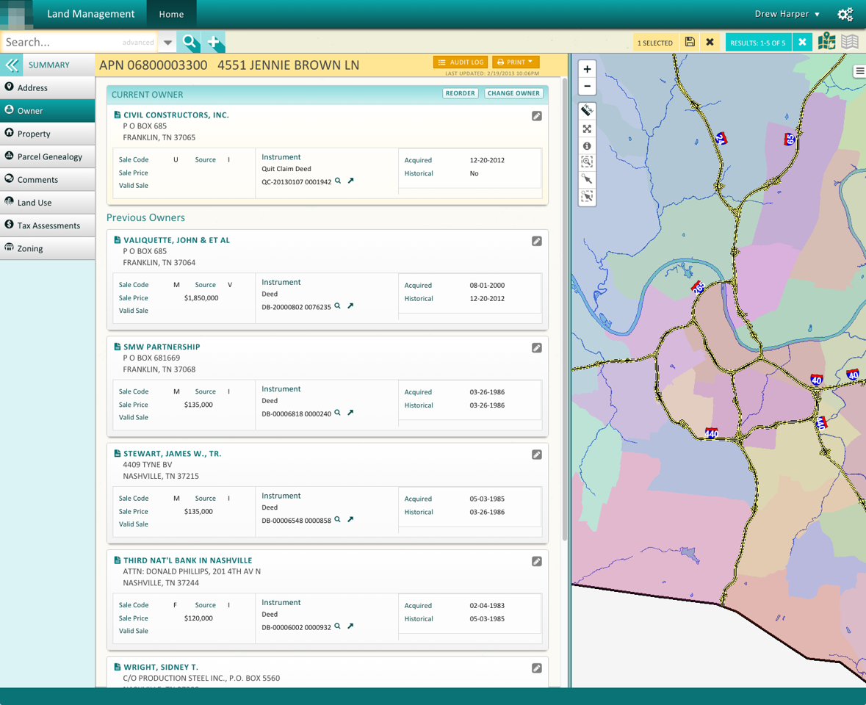

Civic Inc, City Funding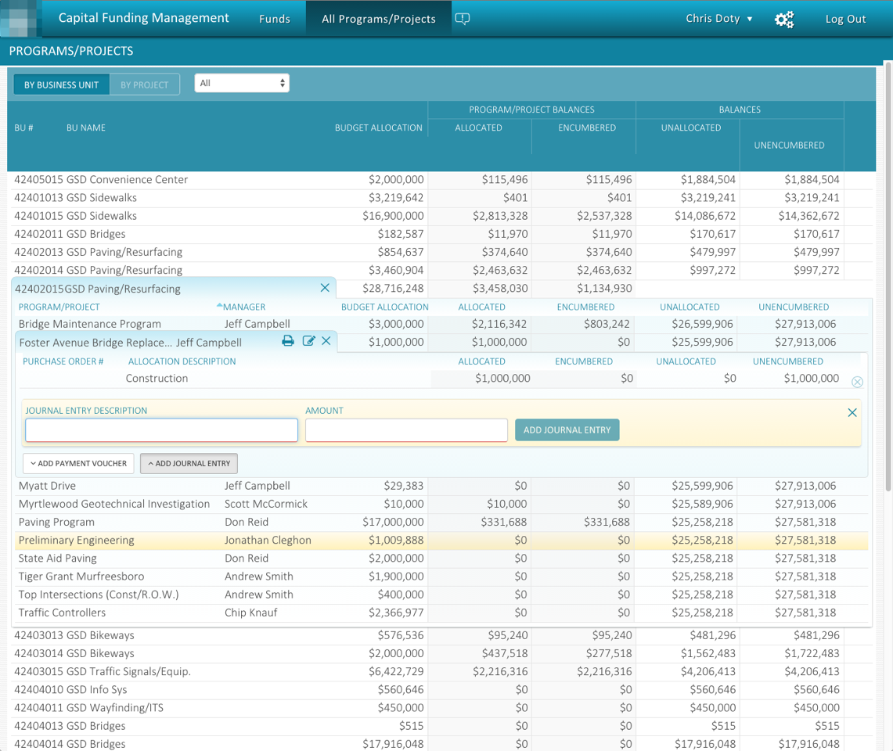

Civic Inc, Permits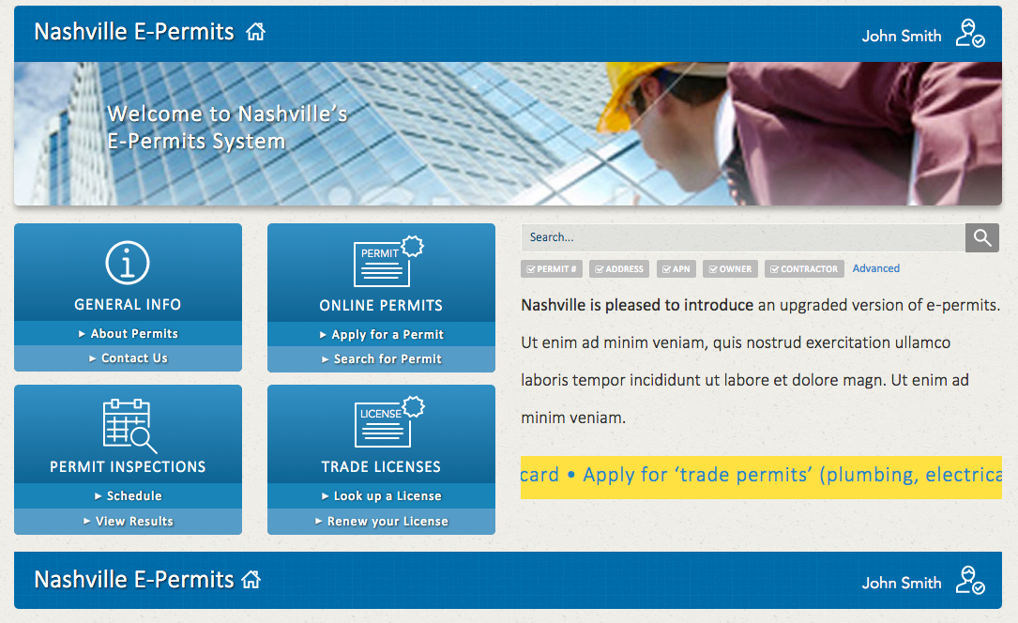

Civic Inc Bikeways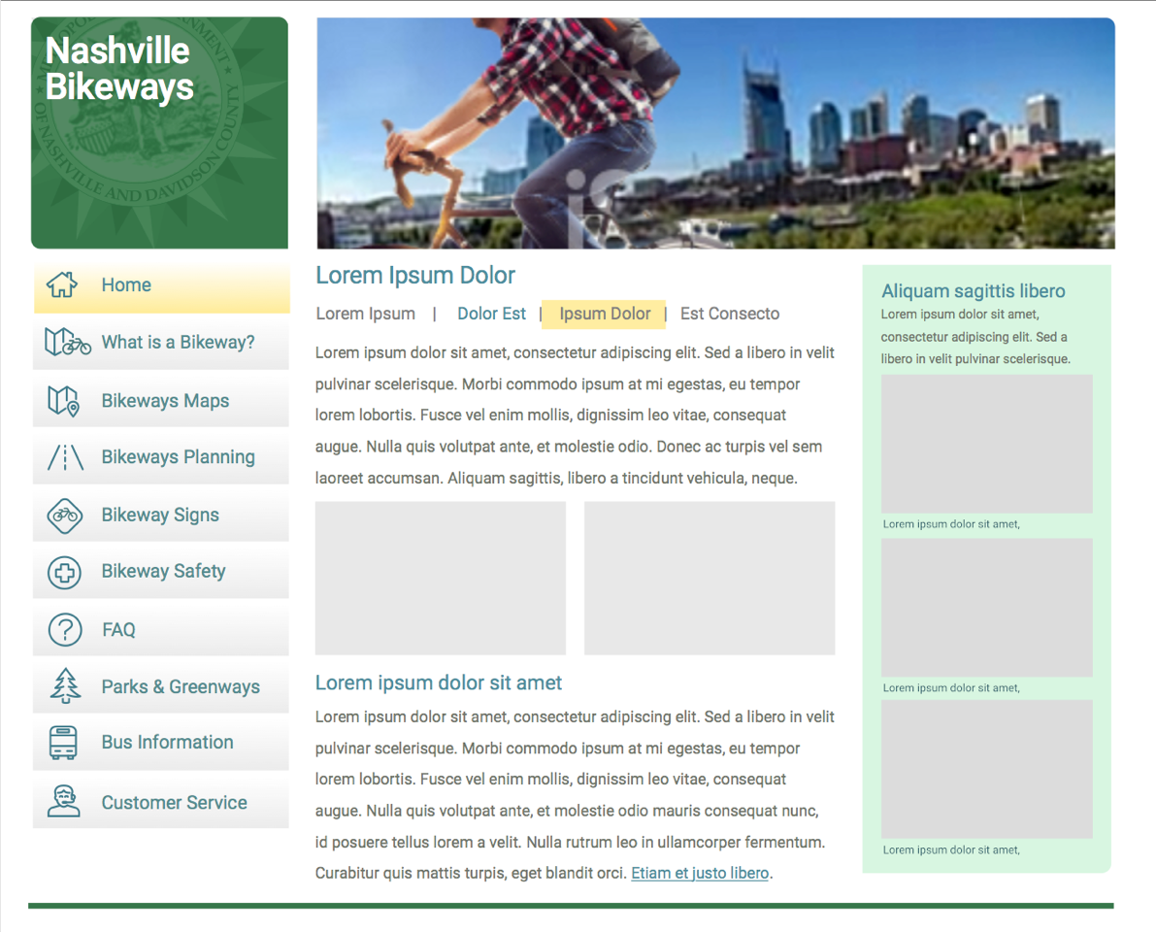

JPay.com website

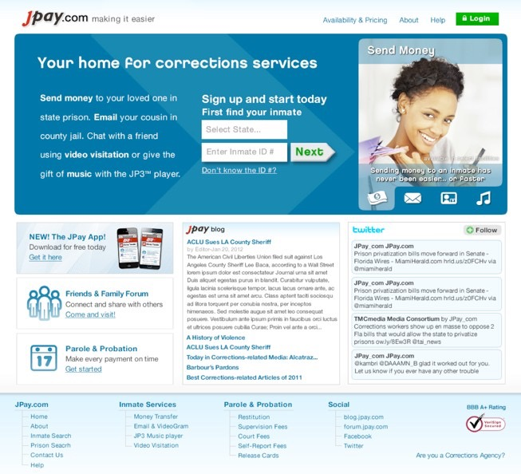

JPay.com website

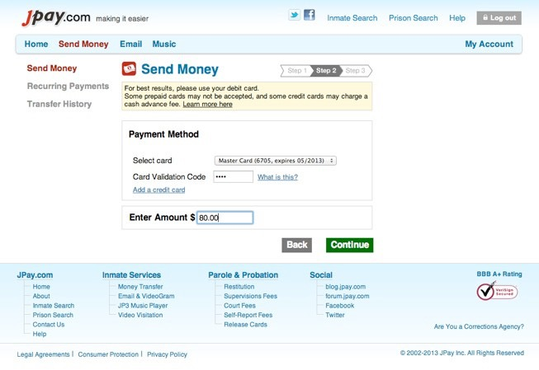

JP4 UI for mini-tablet (for inmates)

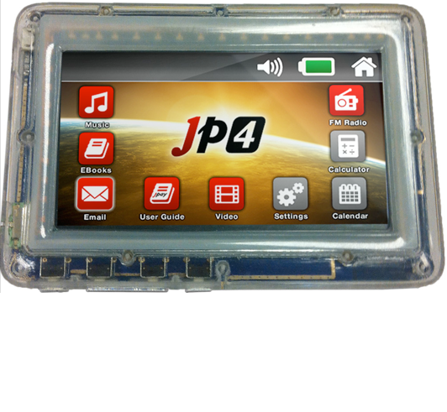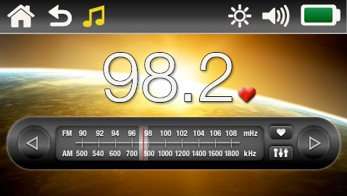

JP4 Radio UI

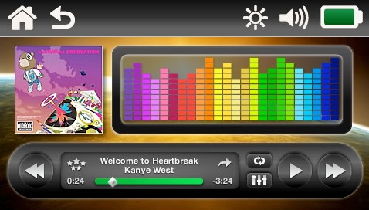

JP4 Music Player

JPay’s JP4

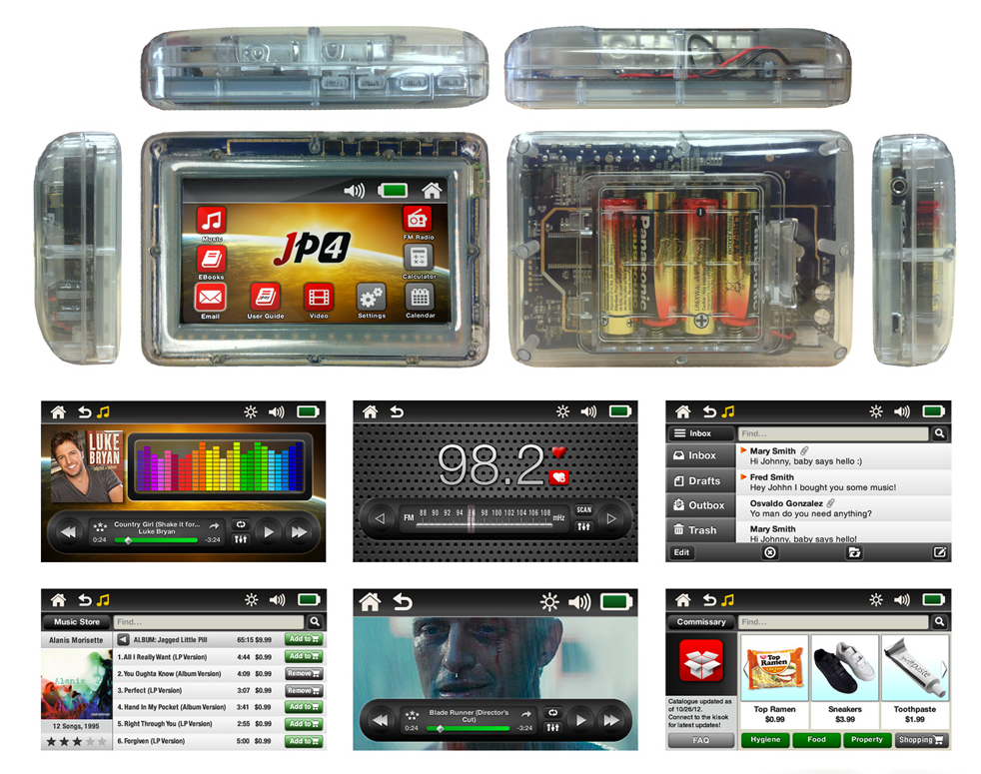

JP4 App

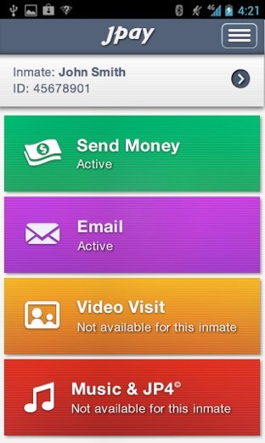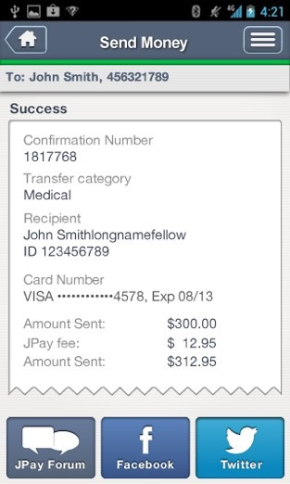

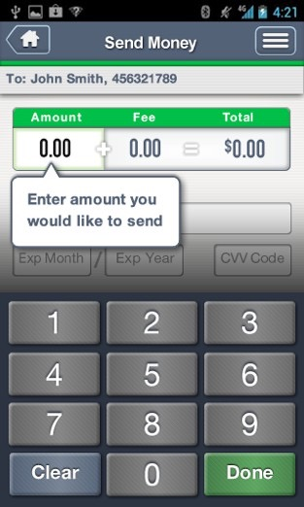 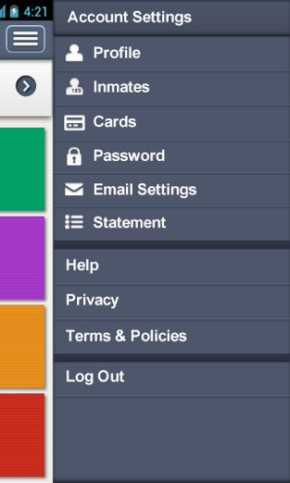

JP4 App – EMail

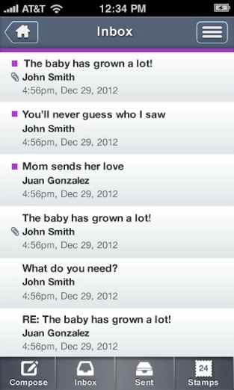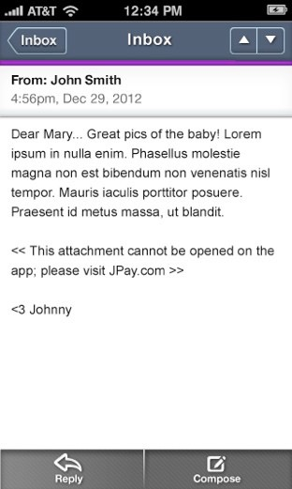

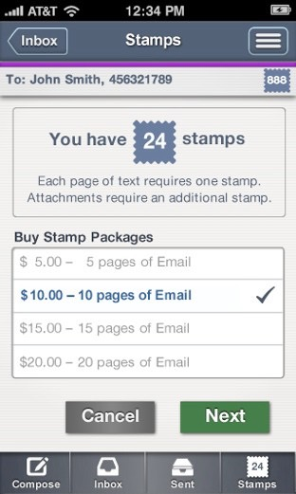 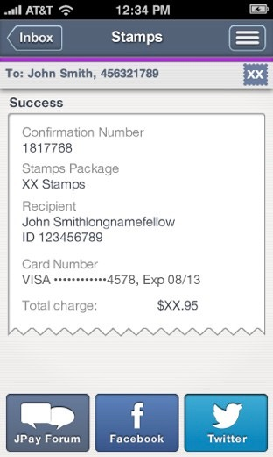

JPay Inmate Kiosk JP3 UI, Buy JP3 player (for inmates)

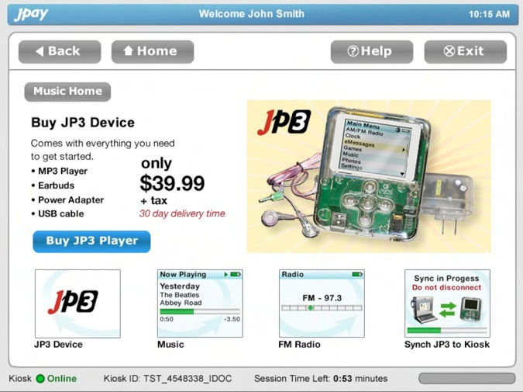

JPay Inmate Kiosk JP3 UI

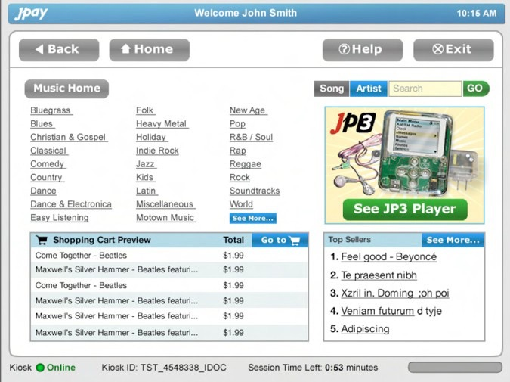

JPay Inmate Kiosk JP3 UI, top albums

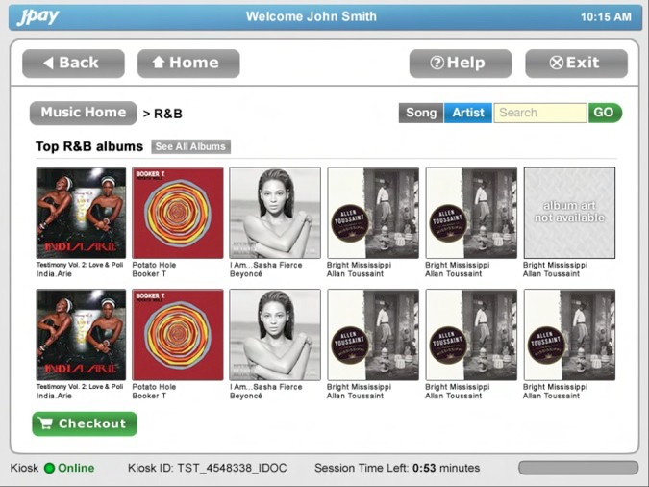

JPay Inmate Kiosk JP3 UI, Song listing

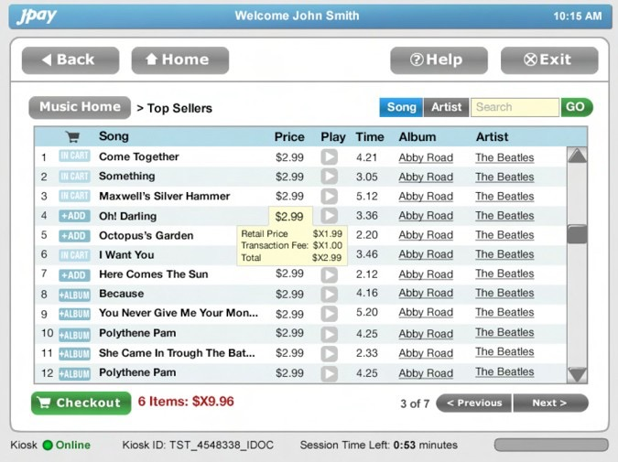

JPay Inmate Kiosk, Email

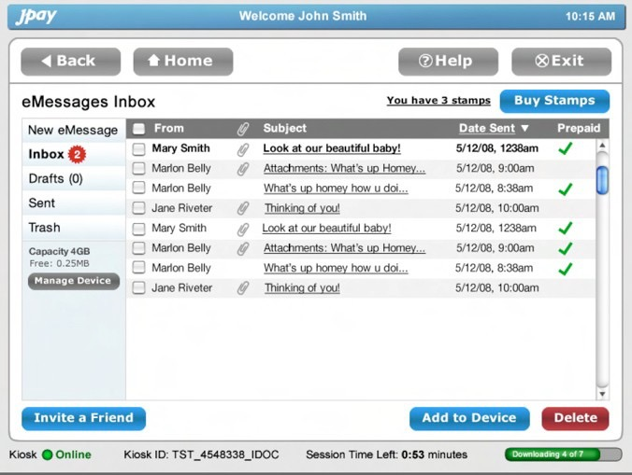

JPay Inmate Kiosk, Email composing

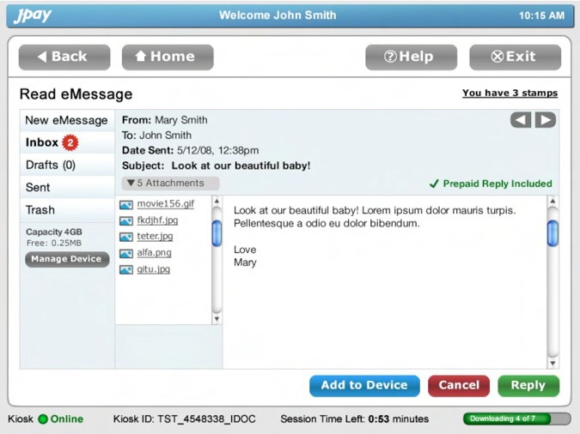

JPay Inmate Kiosk, Email, view photo

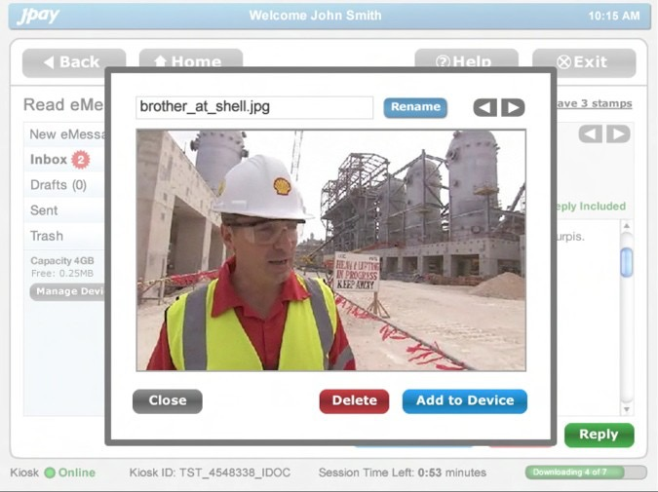

JPay Inmate Kiosk, Music, downloading music

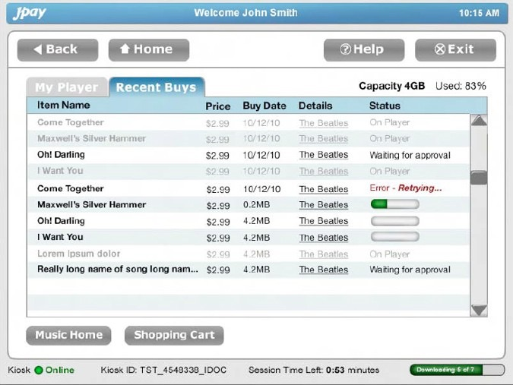

JPay Email

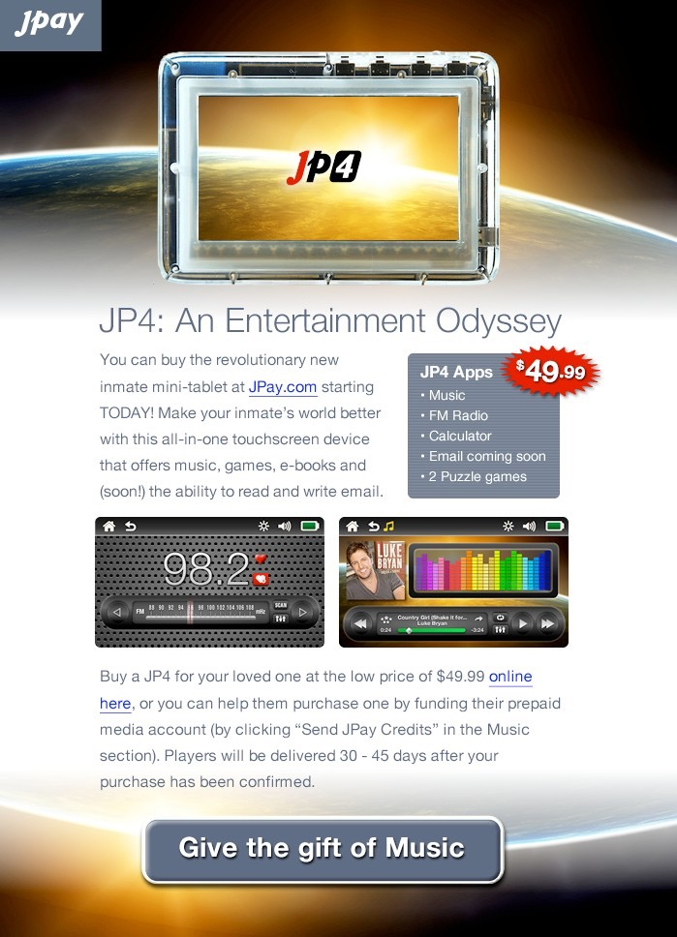

JPay Email

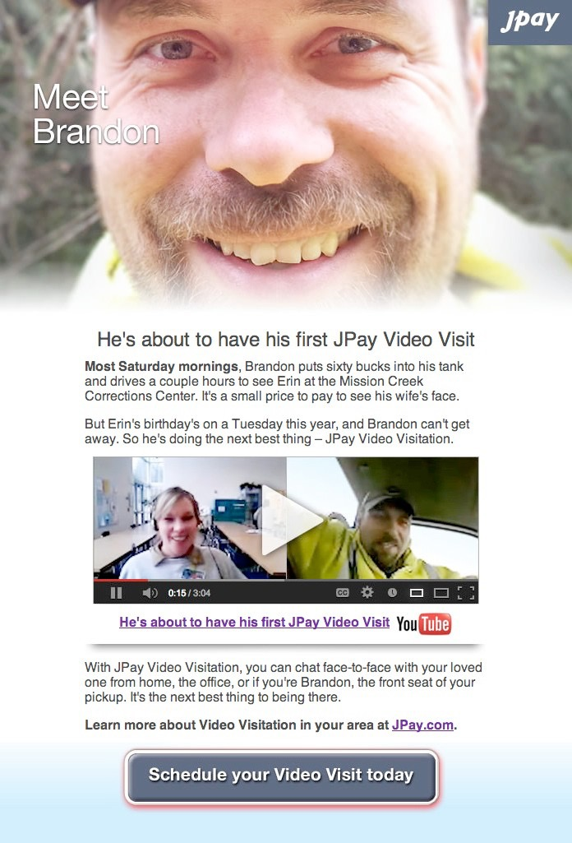

mLotto logo



mLotto app UI

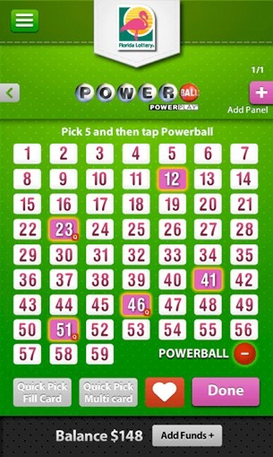 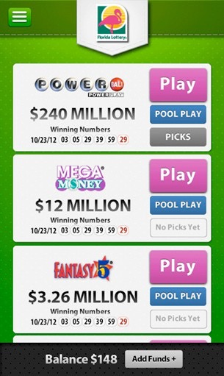

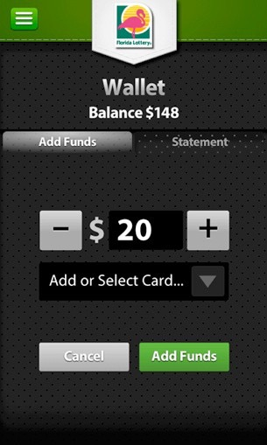 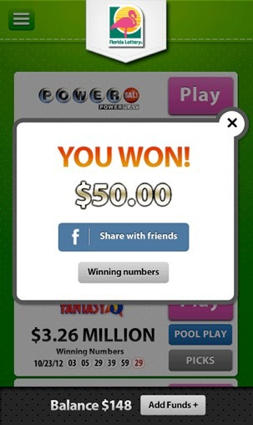 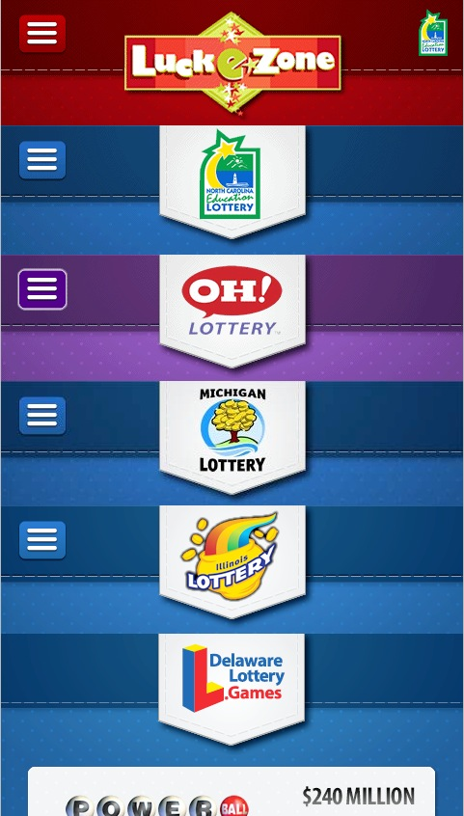

mLotto website

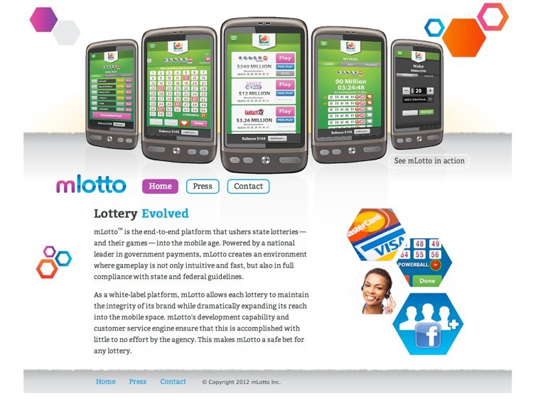

mLotto Brochure spread

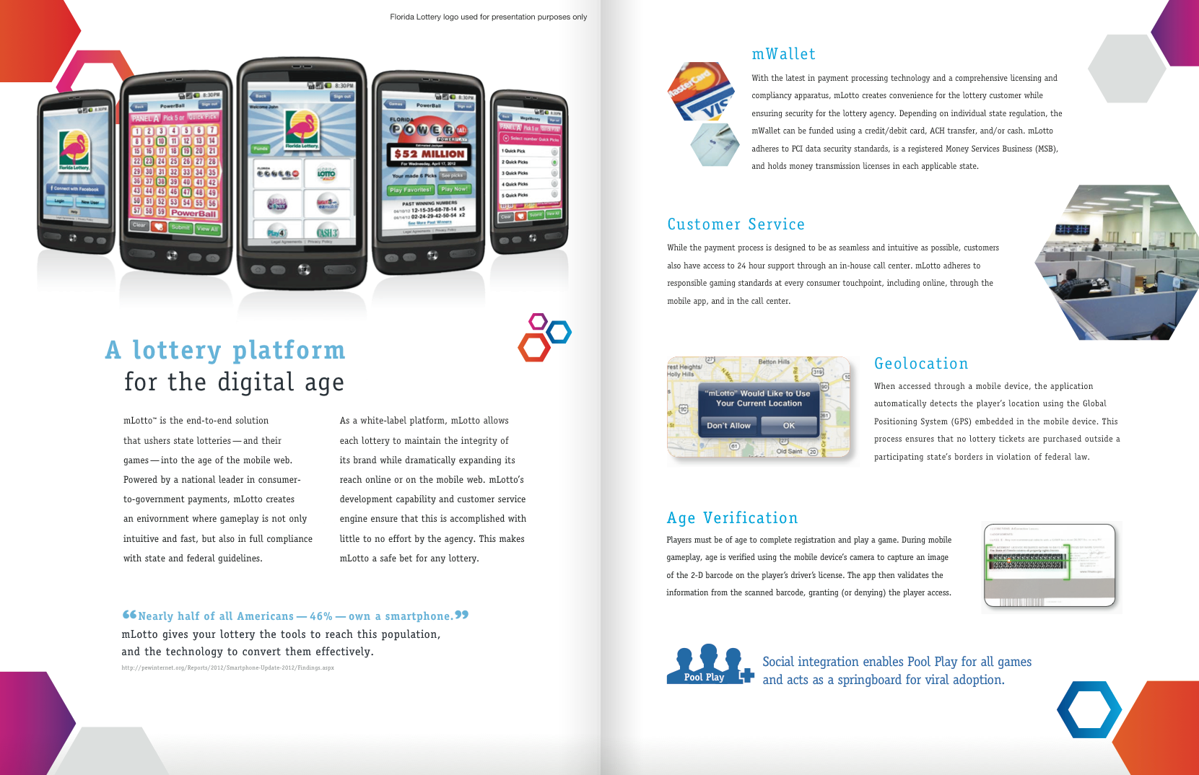

JPayInc.com website

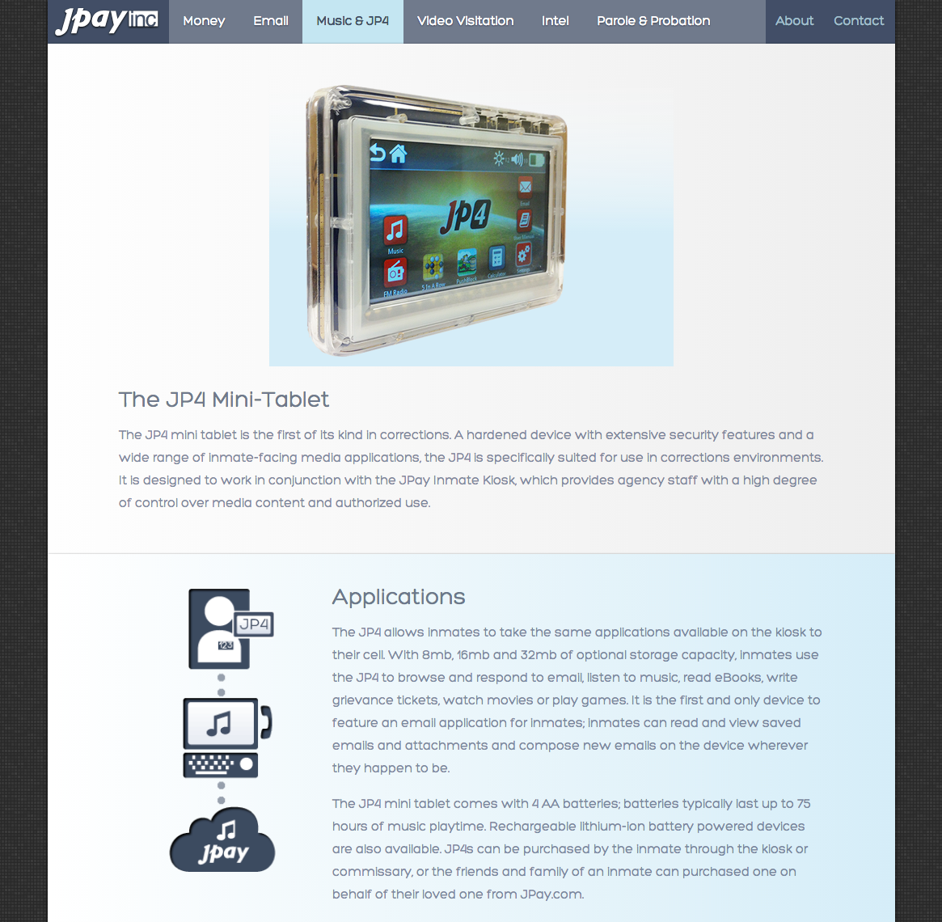 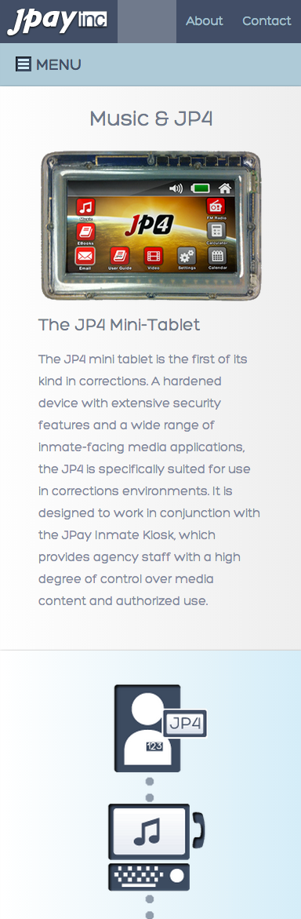

JPay Infographics

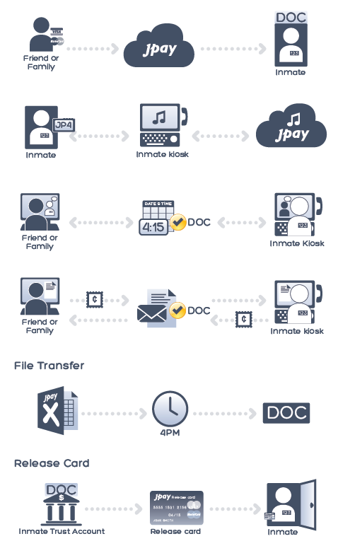

JPay app logo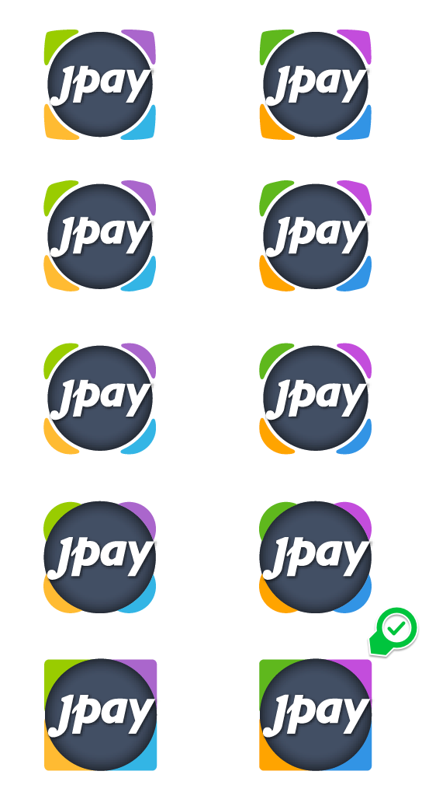

JPay front entrance wall mural

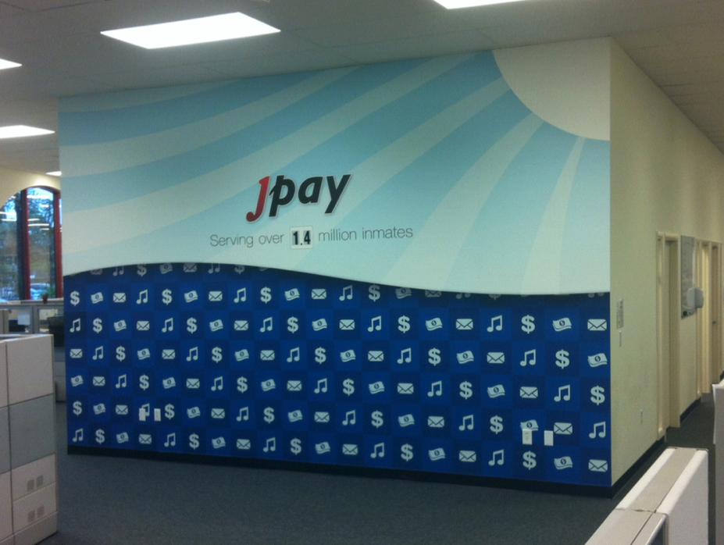

PrisonRide.com website

